Summary of Request:
Qty 2500 pcs assembled, flashed and tested with acrylic piece, two identical PCBs except solder mask color, specified below.
Please quote HASL Lead Free finish.
Please use existing inventory from the 2025 swadge order first from the 015-Magfest warehouse and deduct the cost of materials accordingly.
PCB Properties:
- Two layer board
- Two-side assembly
- 1.6mm FR4
- Qty 1800 COLOR solder mask
- Qty 700 COLOR solder mask
- White silkscreen on both
- V-groove where possible, avoid sharp edges wherever possible. We want to approve tooling locations
- 1oz Copper
- Silkscreen should be sharp, not splotchy
Acrylic Properties:
- One piece of acrylic per-PCB, mockup image is shown below in Assembly section
- Matte Transparent (P422)
  - “Winter Melon White”
  - Edge should be matte, not clear
- 3mm thick
- No engraving

Assembly Information:
18650 holder
Please be aware the part should mount flush to the PCB. If installed backwards, it will stick up on one corner.
TODO ADD IMAGES
The battery cover is designed to be clipped and retained on BT1. Please secure with a little bit of silicone or flexible glue on the BT1 component if there is a concern.
TODO ADD IMAGES
There are 4 THT parts. These parts shall have their leads clipped close to PCB. See notes below.
Through hole leads shall not be sharp.
- 1x Headphone Jack -> J2
  - The jack has a lip that should overhang the pcb. Example of one that doesn’t is shown below. This should overhang correctly and sit flush.
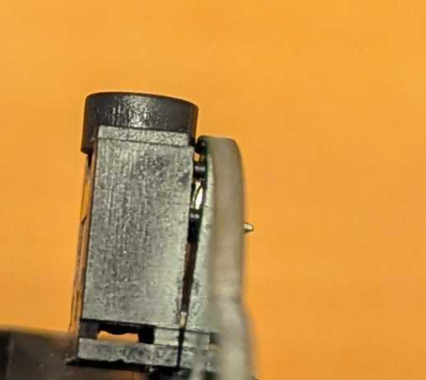
- 1x Switch -> SW1
  - No specific notes for this component
- 1x 3x2 Pin Socket -> J1
  - No specific notes for this component
- 1x Volume control knob -> RV1
  - No specific notes for this component

Screen Assembly:
LCD ribbon shall first be looped through the notch provided in the PCB. Please review photos:
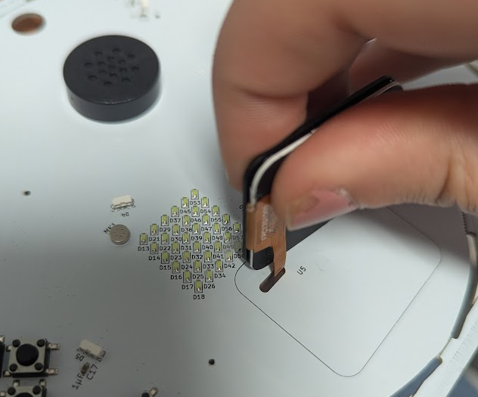
FPC cable connection is on the back of the board.
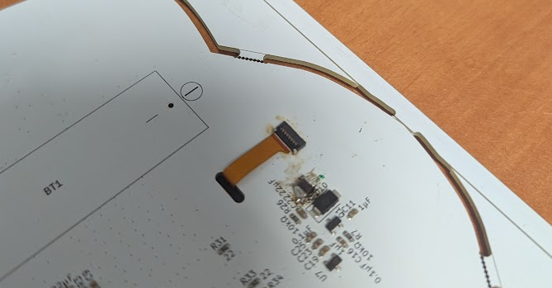
The ribbon cable shall have no twists to be installed – it is simply a fold through the hole to the other side of the board.
LCD shall be taped down after plugging in using double sided tape to PCB. Please use clear, thin, double-sided tape like this 0.1mm PET:
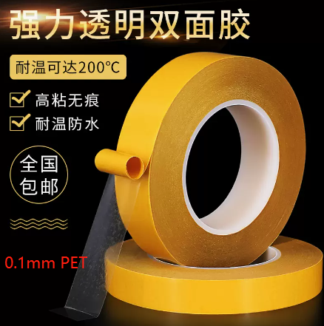
LCD should land approximately within the silkscreen bounds drawn and be straight.

Acrylic Assembly:
Acrylic must have protective paper peeled off and taped to PCB using the same double-sided tape as the display. Acrylic will not be flush with board edges, see diagram below.
Image of Acrylic and board placement. LEDs are adjacent to the acrylic in the circled locations:
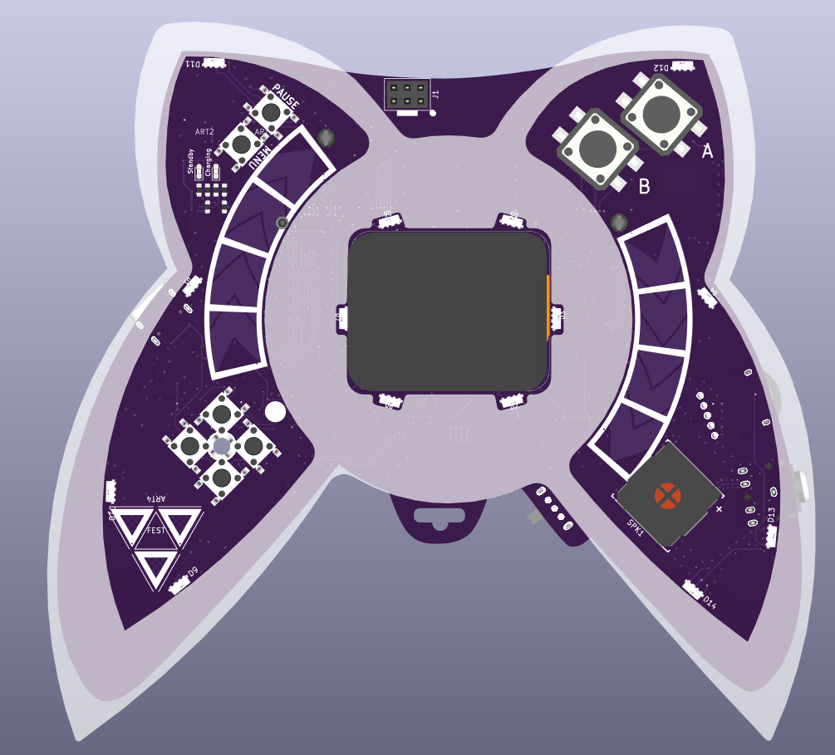It is recommended to apply 4 pieces of tape in the following locations underneath the acrylic, shown as rectangles in red. Do not use glue.
Tape dimensions for the acrylic shall be as follows:
- No greater than 6.35mm in width
- No greater than 18mm in length
Programming:
- A Python programming script will be provided.
- The boards connect with USB-C and do not require external programming hardware
- The programming script can program many units in parallel
- Each unit is programmed in ~15 seconds
Instructions will be provided.
Testing:
- Each unit will be tested after programming.
- Testing involves pressing all buttons and validating the display and LEDs.
- We also have an IMU calibration step which requires the device be held on its face, then its back for 5 seconds each. Then held upright, and upside down for 5 seconds each.
Detailed instructions and video will be provided.

Schedule:
Expected Supplier deliveries:
September 25 2026: Ronbo Electronics ship 2,500 of RB017A1505A-CG01A LCD to Elecrow
Antenk Electronics inc ship 2500 of BBC-M-GO-A-18650-042 to Elecrow

Manufacturing Timeline:
Week 0:
September 14, 2026: RFQ Submitted by MAGFest to Elecrow
September 18, 2026: Quote completed and returned to MAGFest.
Upon Receipt of quote or prior: MAGFest will submit final documents to Elecrow
MAGFest will pay Elecrow for samples and full order.
Elecrow will purchase components for a full 2500 order.
MAGFest will provide basic test firmware for boards.
Week 4:
October 18, 2026: Elecrow will send MAGFest QTY 10 PCBs as samples, via DHL ASAP.
Please do not use re-shipper.
To avoid delays, any components that could not be sourced in time may be unpopulated, we have spares in the USA. Please check with us first.
Please ship with requested 18650 batteries packed separately. Do not wait for injection molded pieces to be delivered.
Week 7:
November 6, 2026: MAGFest will provide feedback needed and will approve the final order of 2500.
Week 11:
November 11, 2026: MAGFest will provide FINAL firmware to be flashed to all units OR direct Elecrow to flash test firmware only at or before this date.
Week 14:
December 18, 2026: Elecrow will ship MAGFest full 2500 order via DHL ASAP.
Please do not use reshipper.
Please ship with requested 18650 batteries installed.

Expect delivery in Maryland, USA on or prior to December 25 2026.

Changelog:

